Regular Expression -Examples

Website: regexr.com from testing regular expressions

The regular expression is it own language the pattern is written within /[some character ]/g, g represent global

**Examples**

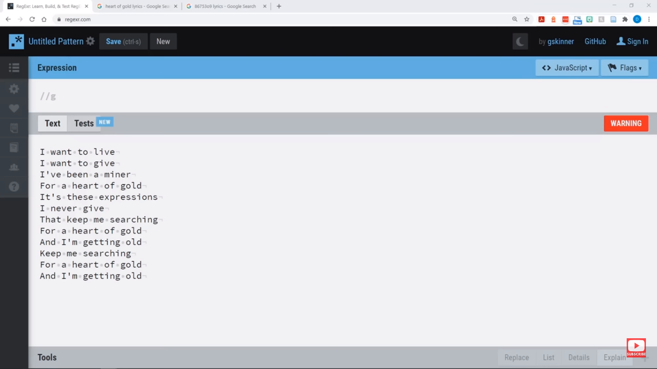

It match the pattern that are written within /[ ]/

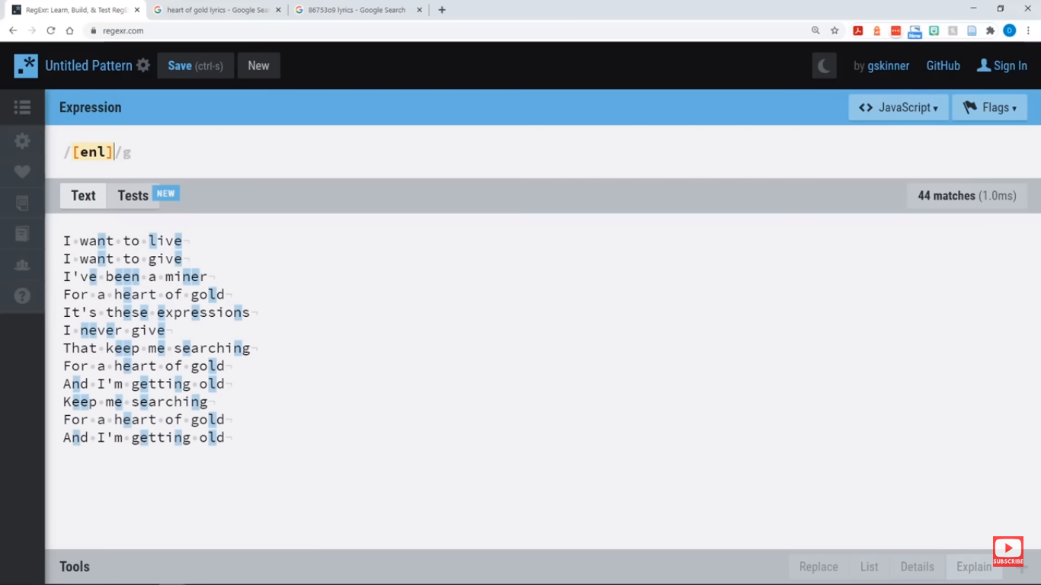

Now if matches all the character except “enl”, ^ start with and $ is end with

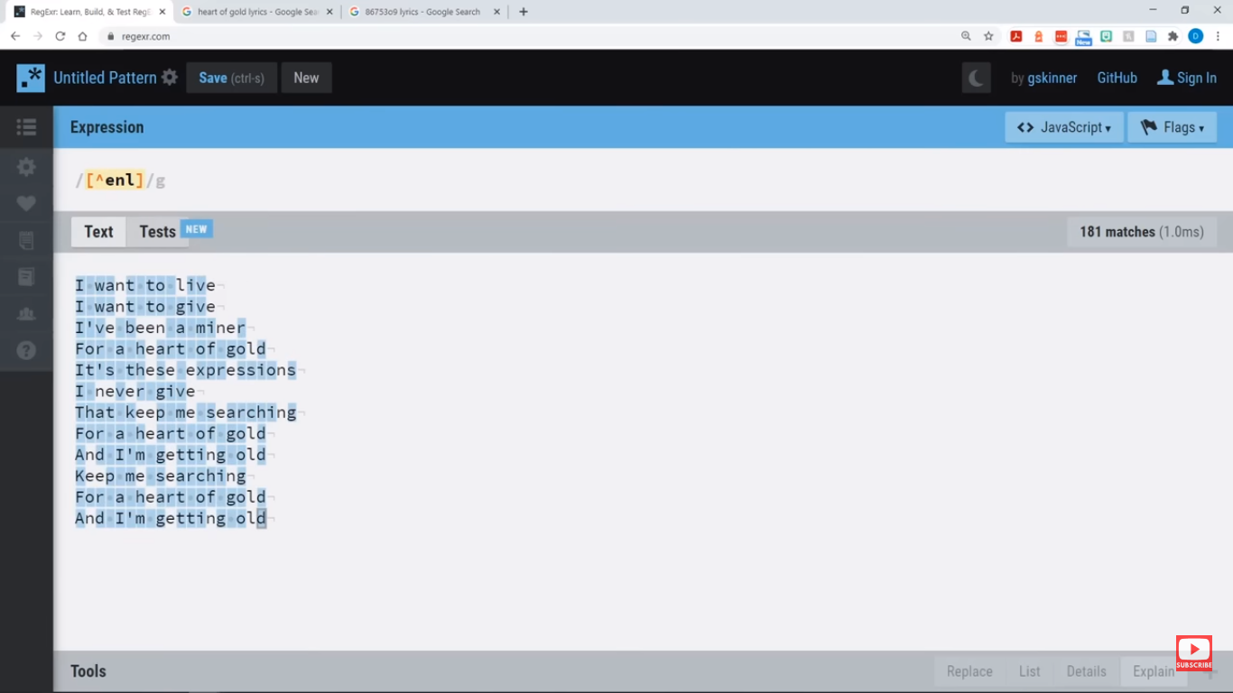

**Range in regular expression using “-” character**

In this example it matches all the character form a to z small alphabet

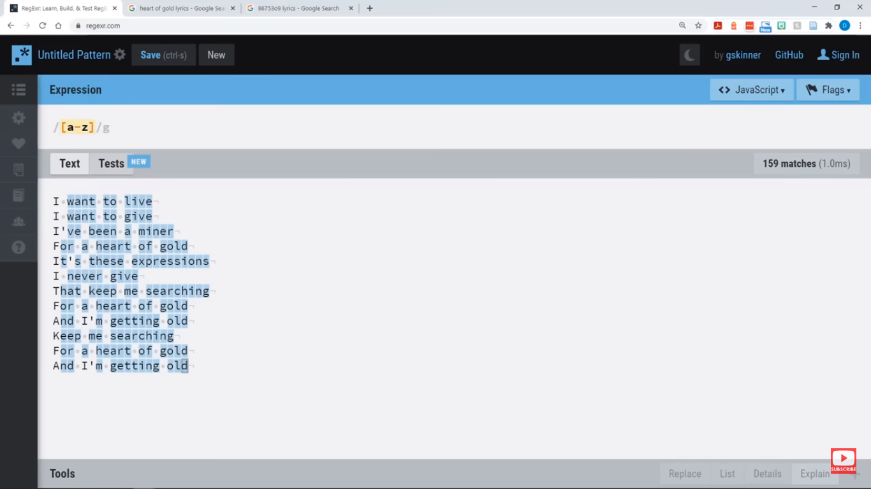

Matches all the capital letter A to Z

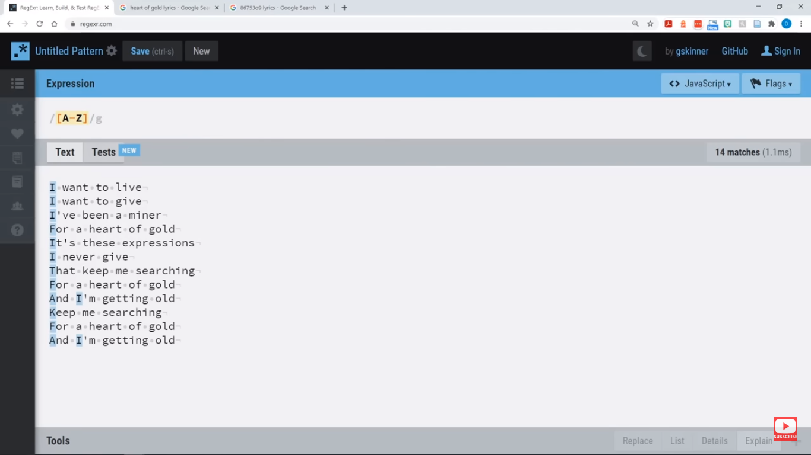

Numbers matches

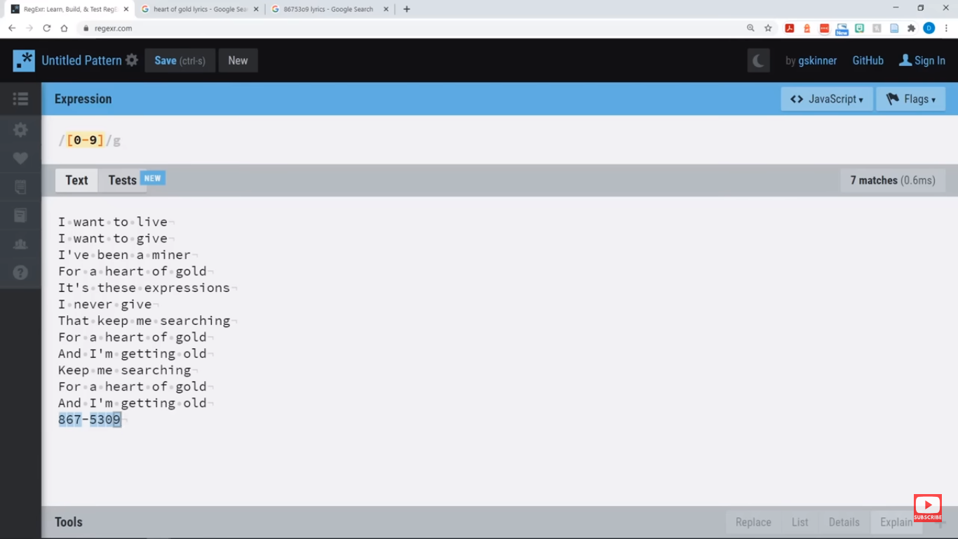

All word characters \w all alphabets and number except special character or .,-,+,=,””,::,

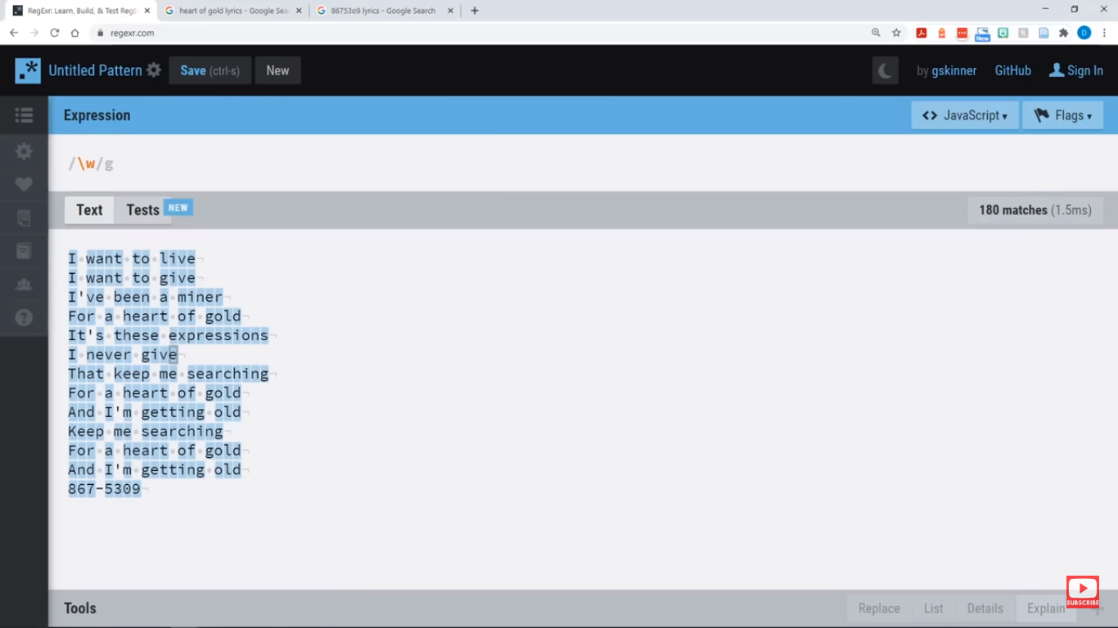

Opposite of \w is \W

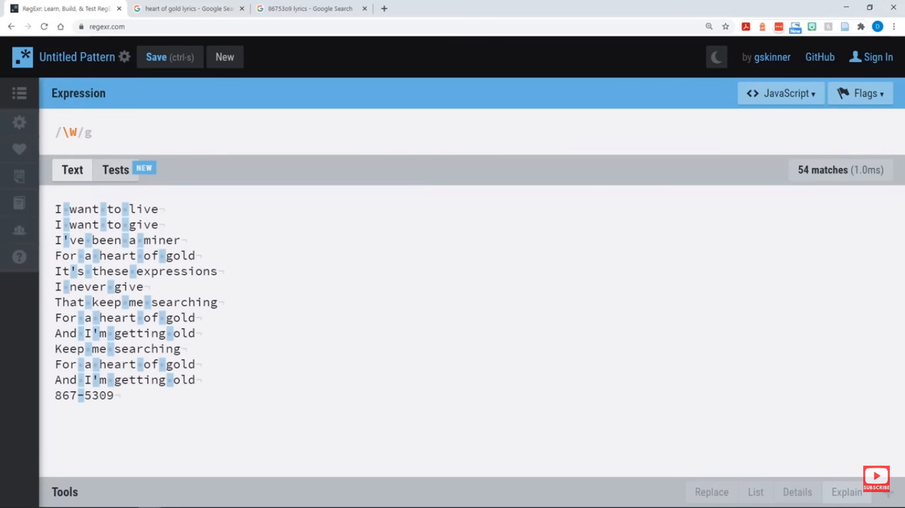

Number only \d

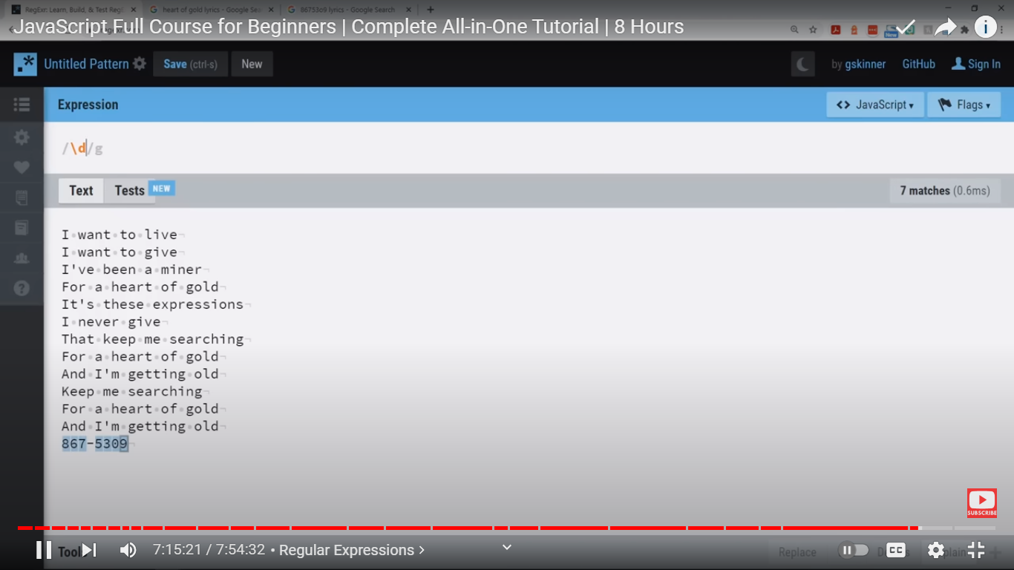

Except number all character including -, = special char

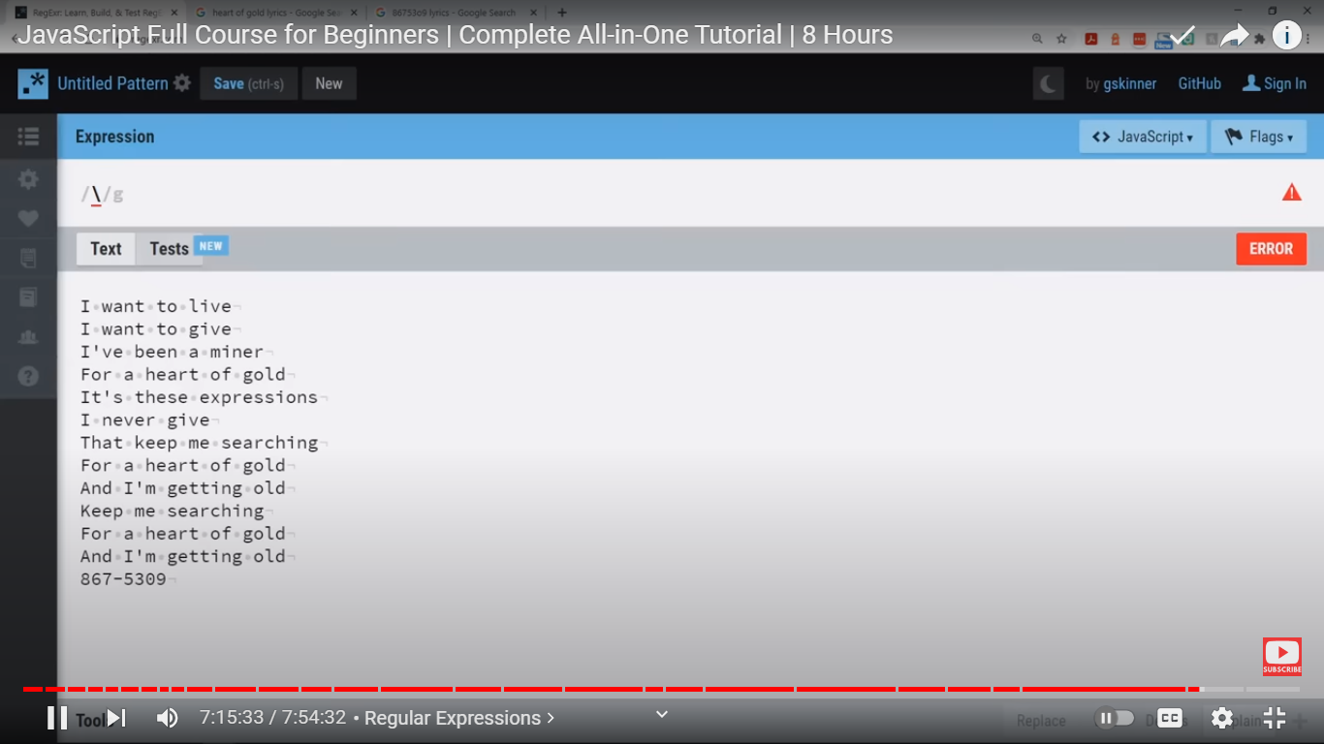

White space \s



Opposite to white spaces \s is \S

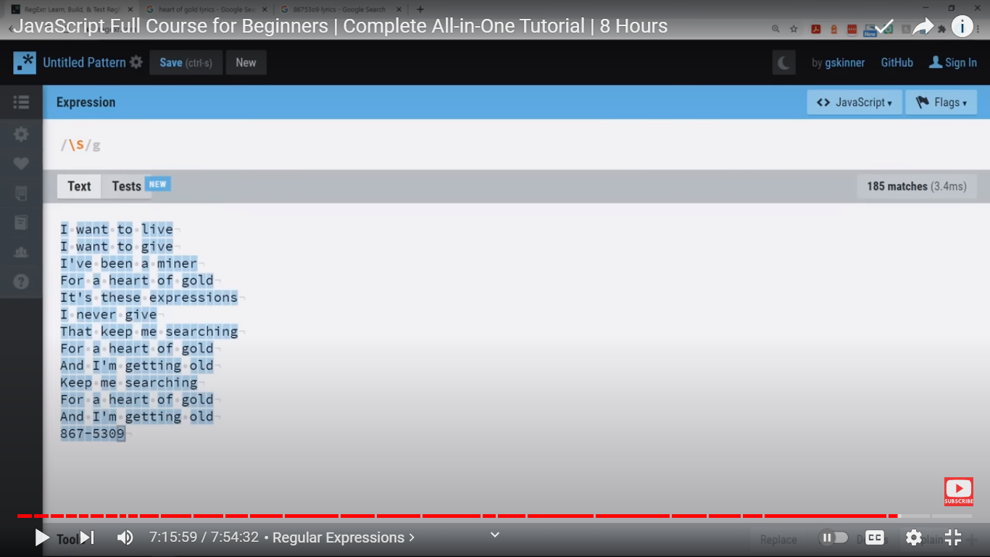

Matches everything



Combination of everything that is white spec and everything that does not white space

